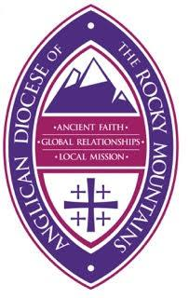 | Anglican Diocese of the  Rocky Mountains  College of Deacons  Board Member Application

Thank you for your interest in becoming a member of the Board of the College of Deacons for the Anglican Diocese of the Rocky Mountains. Please use this form to provide information about yourself that you would like to be considered during the selection process. The information will be shared with members of the Board and Bishop Ken Ross.

Name:

Primary Phone Number:

Address

Email Address:

Parish:

Date of Ordination:

Please describe your current ministry within your parish and in the community:

Briefly explain why you would like to be on the Board of the College of Deacons:

What skills do you have that you feel would be helpful as a member of the Board of the College of Deacons?

Please include any additional comments that you would like to be considered during the selection process:

If you are elected to the Board of the College of Deacons for the Anglican Diocese of the Rocky Mountains, you will be expected to participate in scheduled phone conferences and assist with other activities that are organized by the Board of the College of Deacons. By typing your name in the boxes below, you are agreeing to these expectations.

Your Signature:

Date (DD/MM/YYYY):

